**Abhiram Basa**

**Assessment 2 of Data Engineering - 05/12/23**

Today we learned about databases, sql , sql commands and implemented all of them using **MySql studio**.

**Infrastructure of Application:**

It contains mainly 3 components

Web server

App server

Database

**RDBMS:**

Relational database contains data in form of tables.

**Sql uses:**

Speed

Reliability

Ease of use

**LAMP COMPONENTS:**

Linux.

Apache http server.

MySql.

Php or perl or python.

**Client server interaction:**

Makes a query

Server

Get results

Client

**Sql Commands:**

1. **DDL commands**
   1. CREATE
   2. Drop
   3. Alter
   4. Truncate
   5. Rename
   6. Comment
2. **DML commands**
   1. insert
   2. Update
   3. delete
3. **DCL commands**
   1. Grant
   2. revoke
4. **DQL commands**
   1. select
5. **TCL commands**
   1. Commit
   2. Save point
   3. Roll back

**SQL commands implementation:**

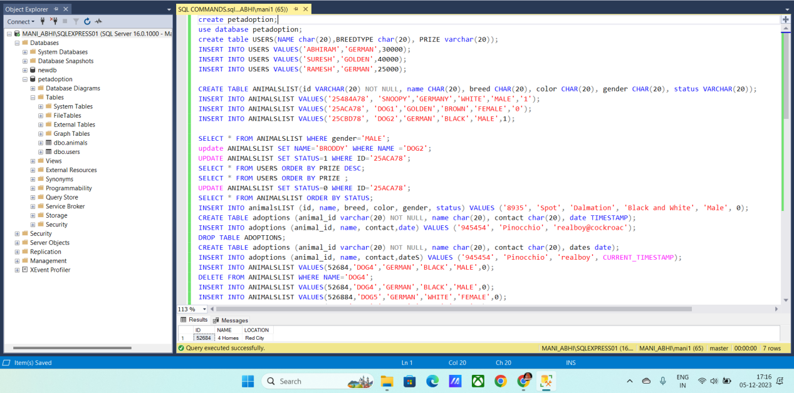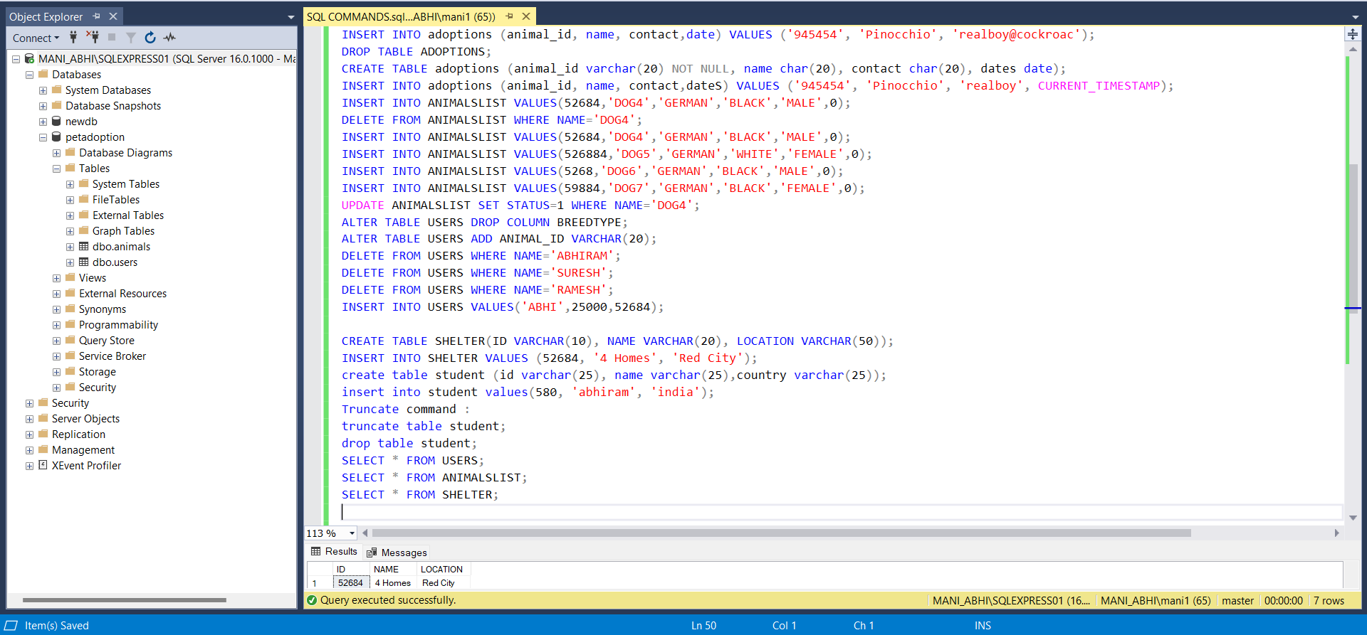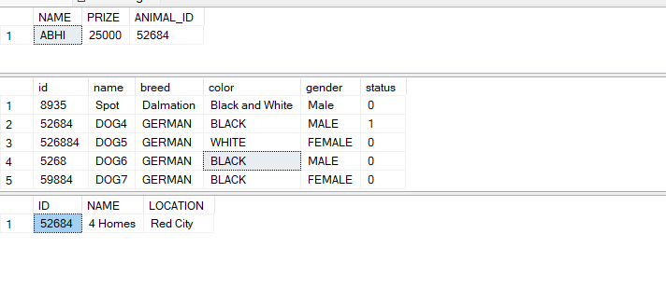

First we created a database called “pet adoption” and then we used it.

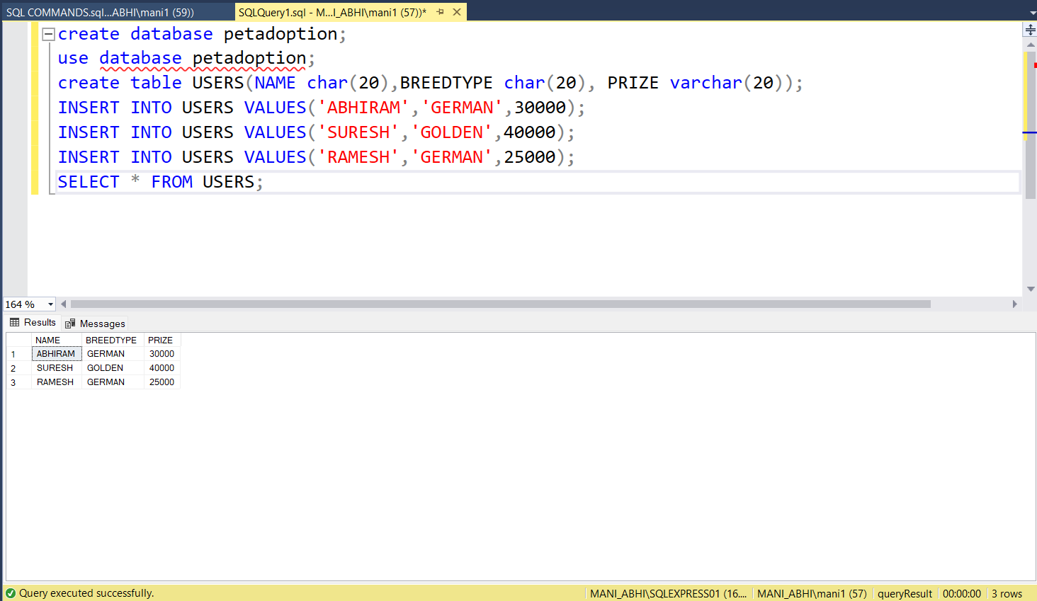

Created a table called USERS and inserted values into it, using **insert** statement.

We can view the table using SELECT statement.

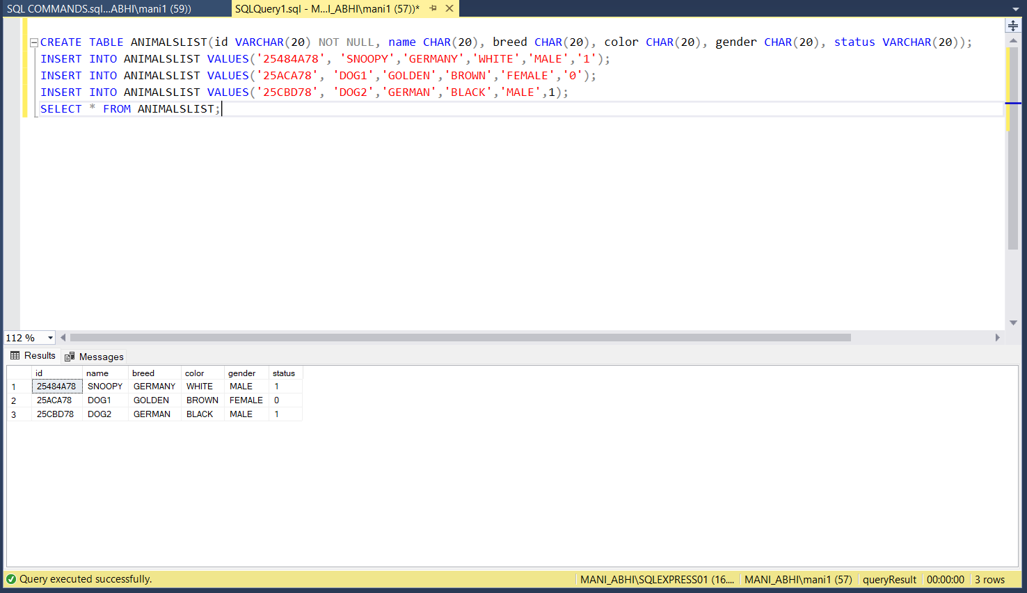

Displaying all the details from animal list table using WHERE clause.

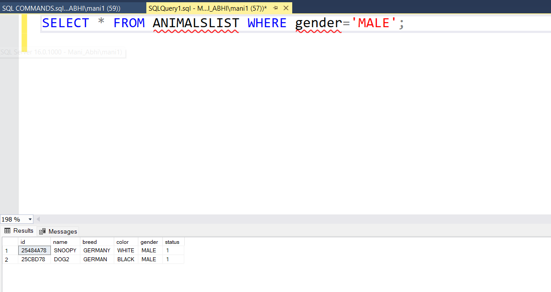

Updating the table using update statement and WHERE clause.

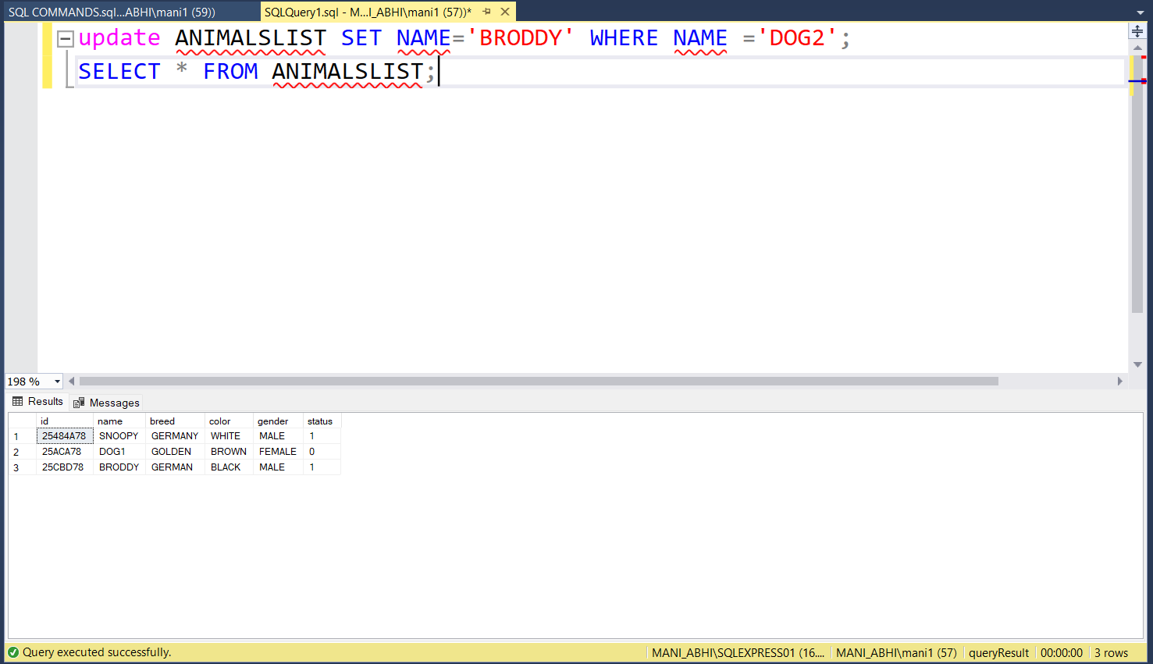

ORDER BY statement

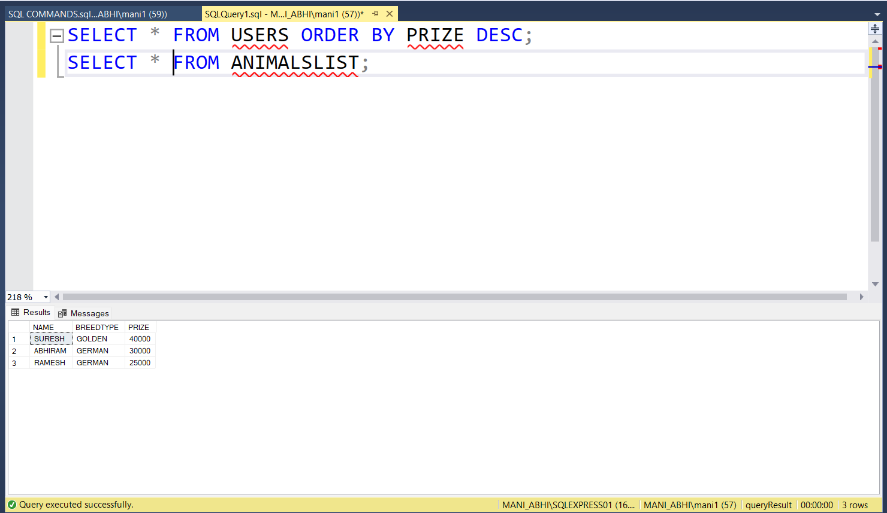

**DROP TABLE USING DROP STATEMENT**

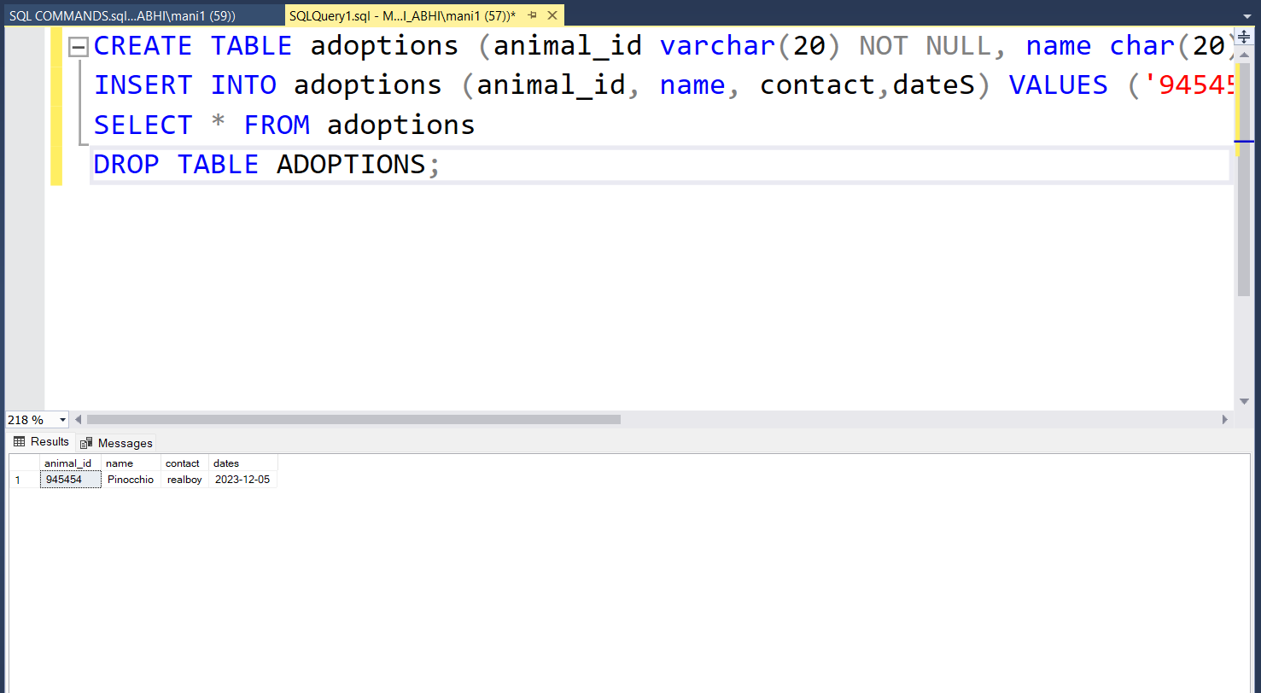

**DELETED THE NAME VARIABLE USING DELETE AND WHERE STATEMENT**

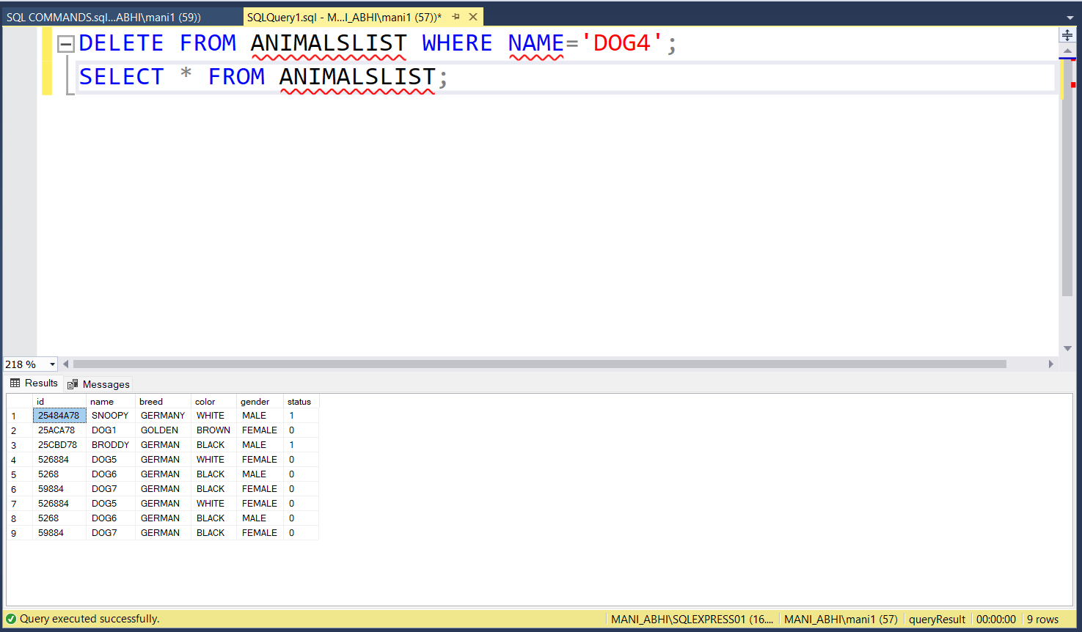

**Altering table by adding new columns using ALTER statement**.

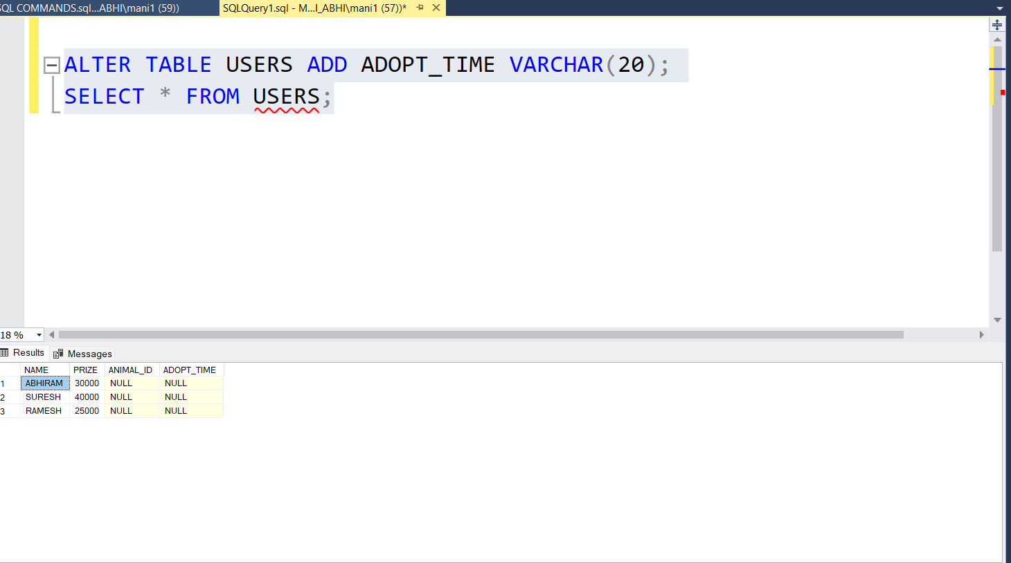

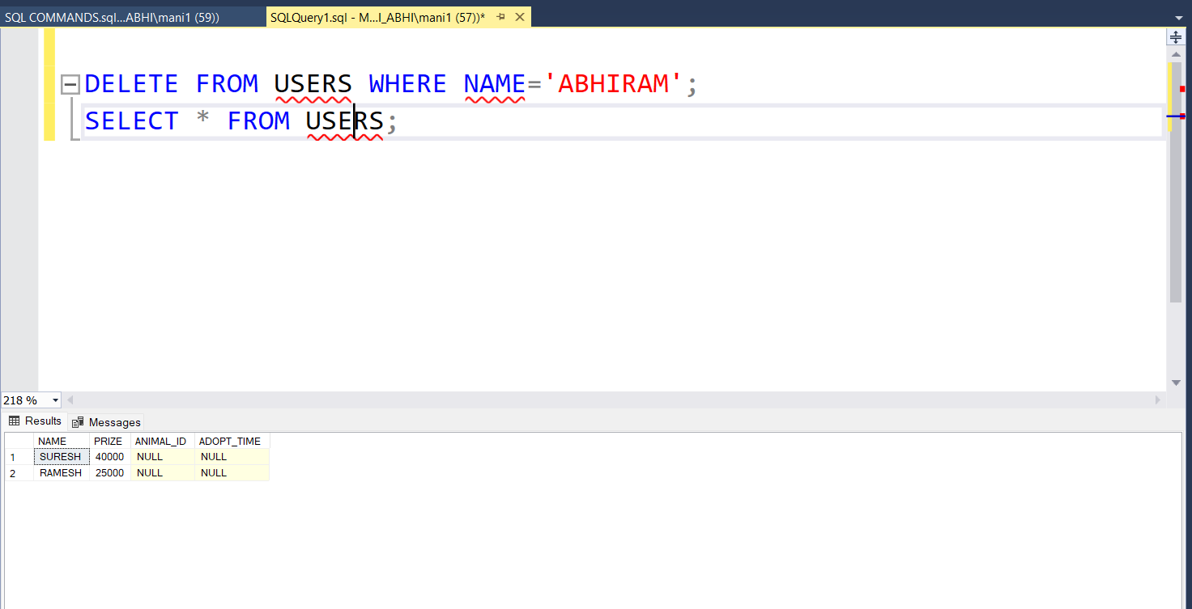

Created a new table called student, and truncated it. It will delete all the data inside the STUDENT table.

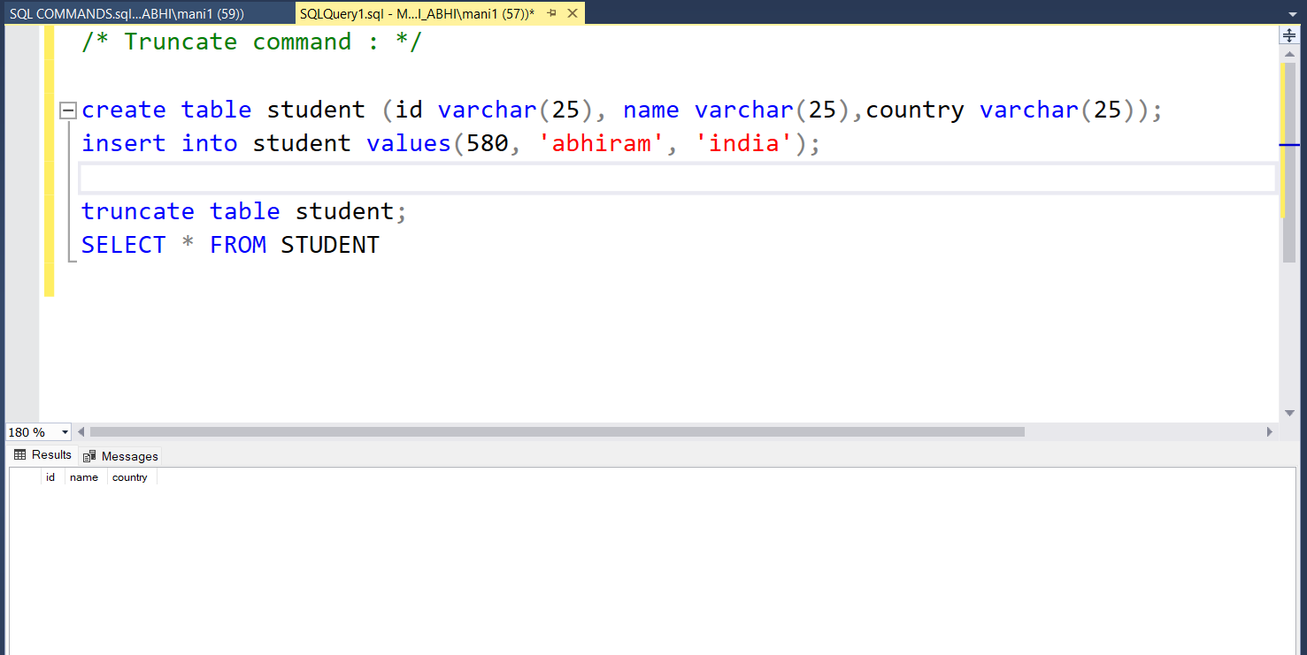

Drop table using DROP statement, it will delete entire table along with the data.

